**21/09/2021 CN SPOT 3 2019103573**

**CONNECTING MULTIPLE CLIENTS WITH A SINGLE SERVER USING SOCKETS TO PERFORM ARITHMETIC OPERATIONS**

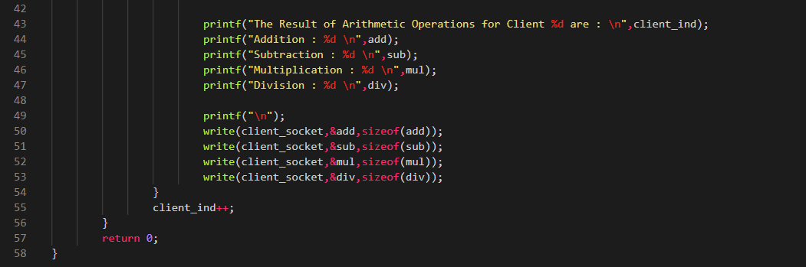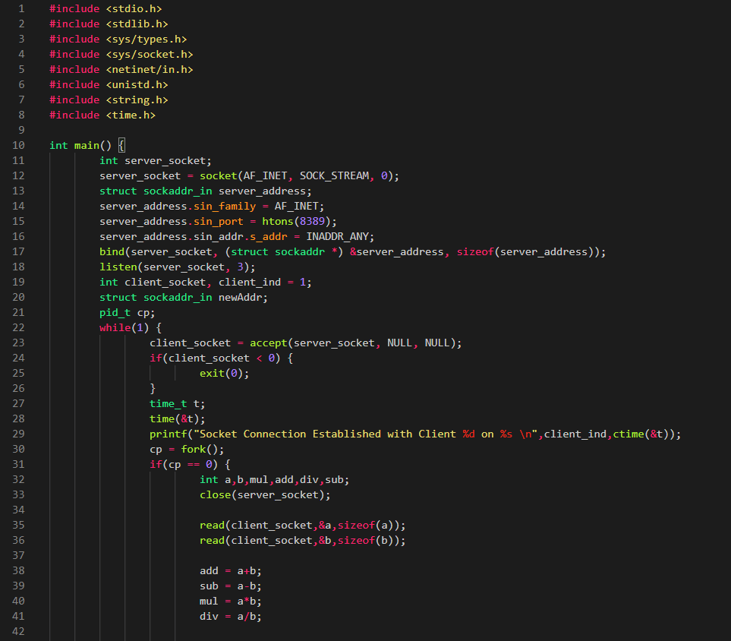**SERVER.C**

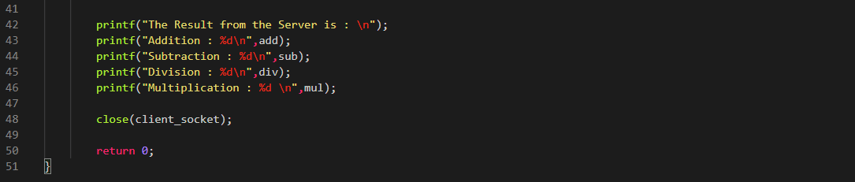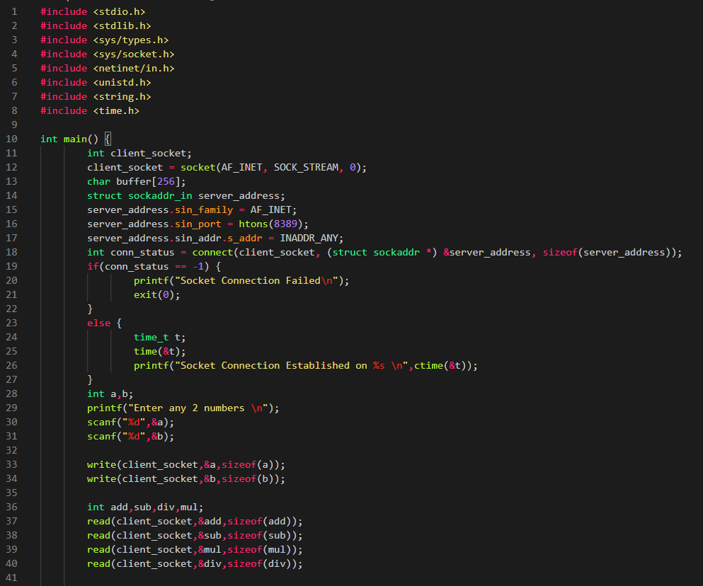**CLIENT.C**

**OUTPUT**

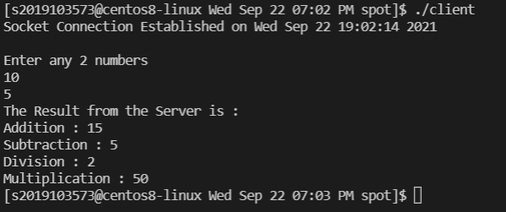**CLIENT 1 :-**

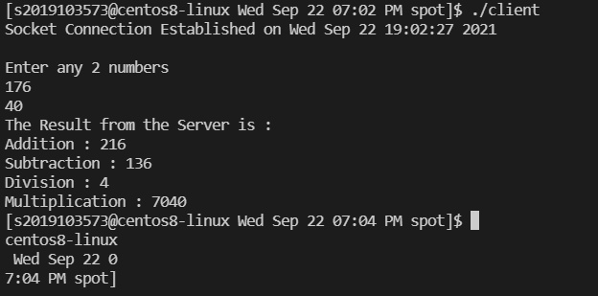**CLIENT 2 :-**

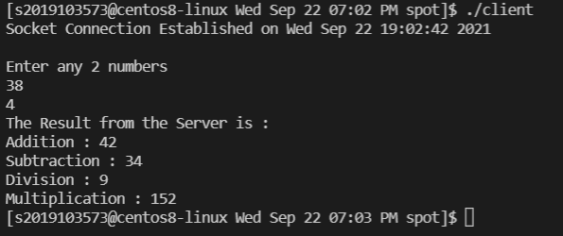**CLIENT 3 :-**

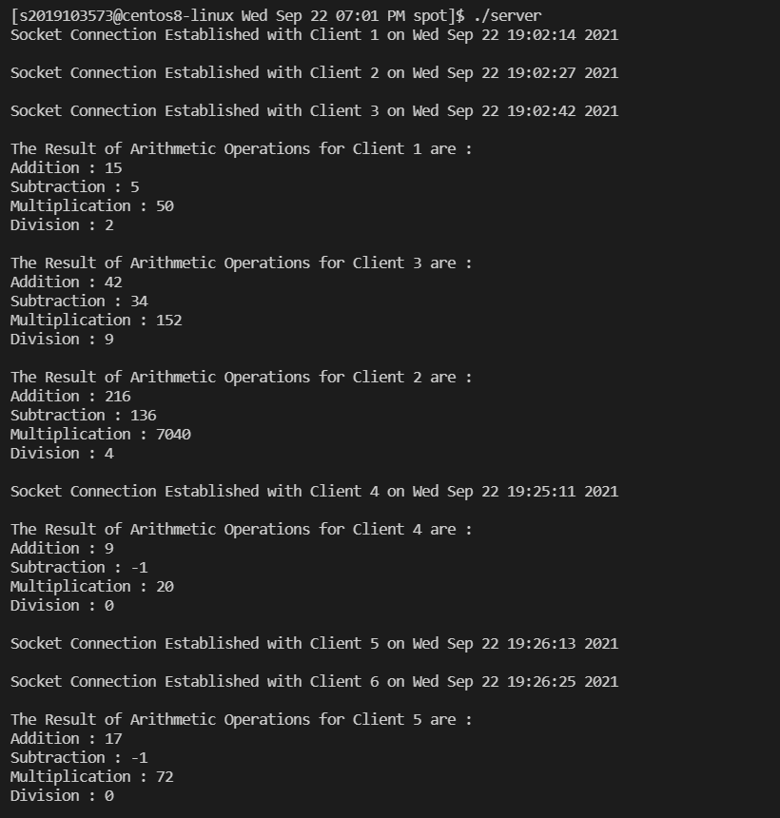**SERVER :-**